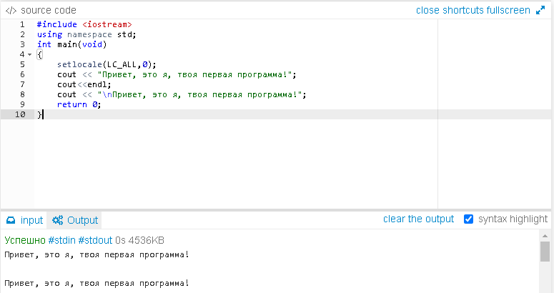

Lab. 1.2

#include <iostream>

using namespace std;

int main()

{

setlocale(LC_ALL,0);

cout<<"Привет, это я, твоя первая программа!";

cout<<endl;

cout<<"\nПривет, это я, твоя первая программа!";

return 0;

}

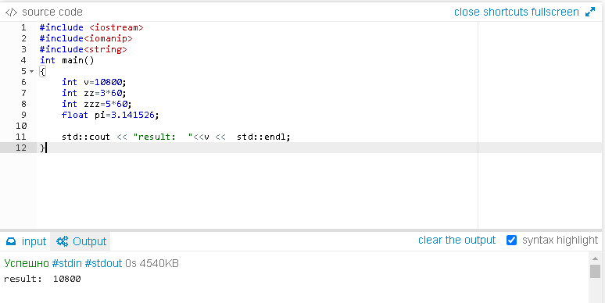

Lab. 1.3

#include <iostream>

#include <iomanip>

#include <string>

int main()

{

int v=10800;

int zz=3*60;

int zzz=5*60;

float pi=3.141526;

std::cout<<"result:"<<v<<std::endl;

return 0;

}

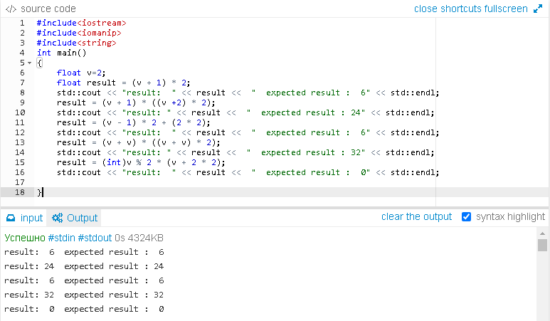

Lab.1.4(1)

#include<iostream>

#include<iomanip>

#include<string>

int main()

{

float v=2;

float result = (v + 1) * 2;

std::cout << "result: " << result << " expected result : 6" << std::endl;

result = (v + 1) * ((v + 2) * 2);

std::cout << "result: " << result << " expected result : 24" << std::endl;

result = (v - 1) * 2 + (2 * 2);

std::cout << "result: " << result << " expected result : 6" << std::endl;

result = (v + v) * ((v + v) * 2);

std::cout << "result: " << result << " expected result : 32" << std::endl;

result = (int)v % 2 * (v + 2 * 2);

std::cout << "result: " << result << " expected result : 0" << std::endl;

}

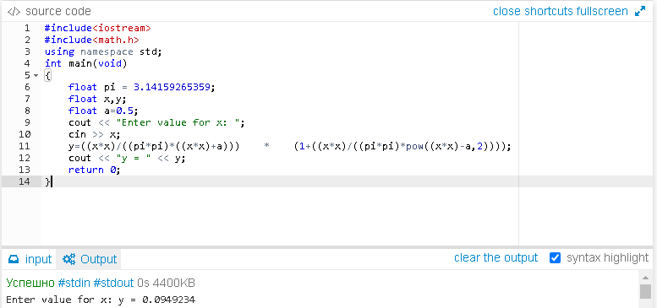

Lab. 1.4(2)

#include <iostream>

#include <math.h>

using namespace std;

int main(void)

{

float pi = 3.14159265359;

float x,y;

float a=0.5;

cout << "Enter value for x: ";

cin >> x;

y=((x*x)/((pi*pi)*((x*x)+a))) * (1+((x*x)/((pi*pi)*pow((x*x)-a,2))));

cout << "y = " << y;

return 0;

}

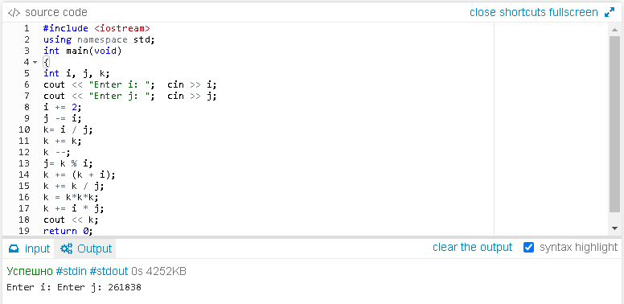

Lab. 1.4(3)

#include <iostream>

using namespace std;

int main(void) {

int i, j, k;

cout << "Enter i: ";

cin >> i;

cout << "Enter j: ";

cin >> j;

i += 2;

j -= i;

k= i / j;

k += k;

k --;

j= k % i;

k += (k + i);

k += k / j;

k = k*k*k;

k += i * j;

cout << k;

return 0;

}

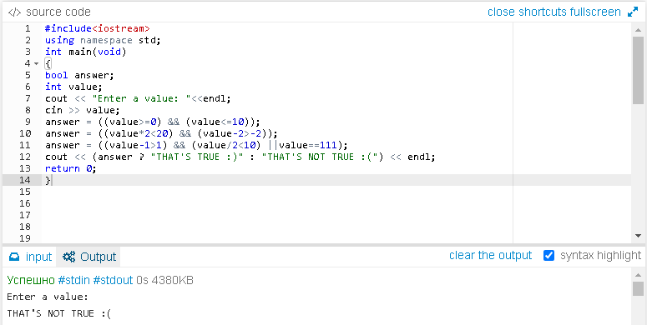

Lab. 1.6

#include <iosteam>

using namespace std;

int main(void)

{bool answer;

int value;

cout<<”Enter a value:”<<endl;

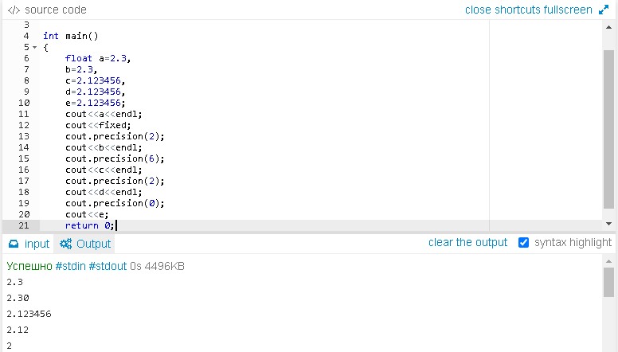

Lab.1.7(1)

#include <iostream>

using namespace std;

int main()

{

float a=2.3,

b=2.3,

c=2.123456,

d=2.123456,

e=2.123456;

cout<<a<<endl;

cout<<fixed;

cout.precision(2);

cout<<b<<endl;

cout.precision(6);

cout<<c<<endl;

cout.precision(2);

cout<<d<<endl;

cout.precision(0);

cout<<e;

return 0;

}

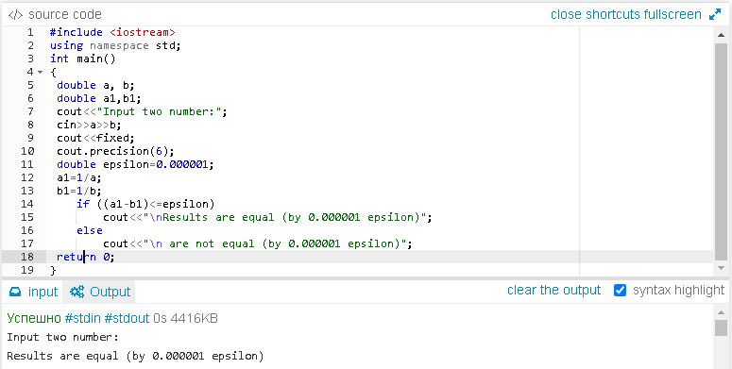

Lab.1.7(2)

#include <iostream>

using namespace std;

int main()

{

double a, b;

double a1,b1;

cout<<"Input two number:";

cin>>a>>b;

cout<<fixed;

cout.precision(6);

double epsilon=0.000001;

a1=1/a;

b1=1/b;

if ((a1-b1)<=epsilon)

cout<<"\nResults are equal (by 0.000001 epsilon)";

else

cout<<"\n are not equal (by 0.000001 epsilon)";

return 0;

}

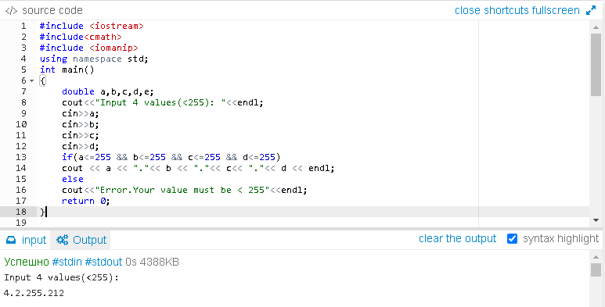

Lab.1.7(3)

#include <iostream>

#include<cmath>

#include <iomanip>

using namespace std;

int main()

{

double a,b,c,d,e;

cout<<"Input 4 values(<255): "<<endl;

cin>>a;

cin>>b;

cin>>c;

cin>>d;

if(a<=255 && b<=255 && c<=255 && d<=255)

cout << a << "."<< b << "."<< c<< "."<< d << endl;

else

cout<<"Error.Your value must be < 255"<<endl;

return 0;

}